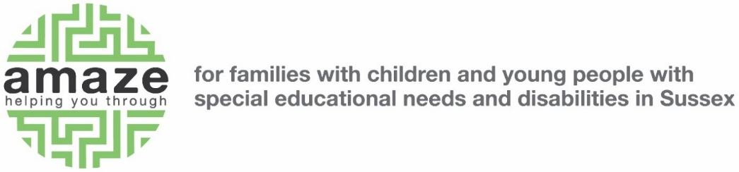

# Guide to writing cover letters for Amaze

We request a CV and a cover letter for all job roles. Please follow this guidance to writing your cover letter, or application statement.

We score based on your CV and cover letter on a scale of 0-3, where 0 is not meeting expectations and 3 is exceeding expectations. Applicants who score highly will have included information on how they meet the person specification and a relevant example.

## Format

Please take each point in the person specification. You can find the person specification at the bottom of the job description.

You should use each point as a heading and write a paragraph under this heading on how you meet this requirement.

Where points in the person specification are similar, or you feel an example would be relevant for both, you can combine these in one heading.

## Contents

Each paragraph should contain an example of how you meet this requirement. Your example should be relevant to the job description and can come from paid work, volunteering or other life experience. You should include the impact of your example.

## Length

We do not have any length restrictions on our cover letters. Please include as much detail as you feel you need to show you meet the person specification. We suggest you ensure your cover letter is at least one A4 page at 11pt Arial font. But using one relevant example for each point on the person specification should mean the statement is not too long and usually one to three pages will be enough.

## Using AI

We celebrate the benefits that AI can bring to our work and use AI as part of our operations. However, in our experience, AI generated cover letters do not have the right structure or content. They rely heavily on certain words and phrases and do not follow a sentence or paragraph structure. We encourage candidates to not over-use AI and instead use it as a support, rather than a creative production tool.

## Example

Able to use Microsoft Office software including Word, Excel, Teams and Outlook

In my current position, I regularly use Microsoft Office to manage a variety of tasks. Our team collaborates using Microsoft Teams, sharing documents and having meetings. I recognised that there were some gaps in our processes. I took the initiative to watch a Microsoft training webinar to understand Microsoft Teams better. As a result of this, I was able to make some suggestions to improve our processes. We now use Forms on teams to give updates, and this has made our team meetings more efficient. I am comfortable at learning new processes and ways that teams communicate so I would be able to adapt if I was successful in this role with Amaze.