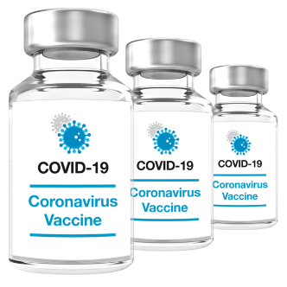 | Having a Covid-19 jab (vaccine)  at the Racecourse
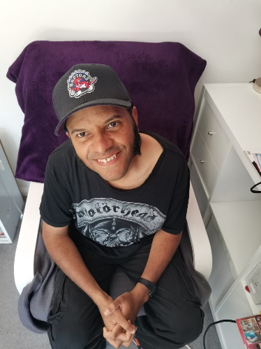 | Hello, I am Mike, I am going to have a Covid-19 jab (vaccine) at Brighton Racecourse.
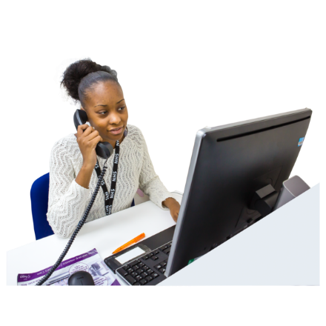  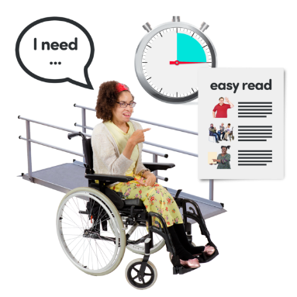 | We phoned, to book my jab (vaccination) at the Racecourse.  Phone: 0300 303 8060  We told them that I have a learning disability and need, more time, a quiet space and things explained to me in easy words.  We also told them what has helped me to have jabs in the past.
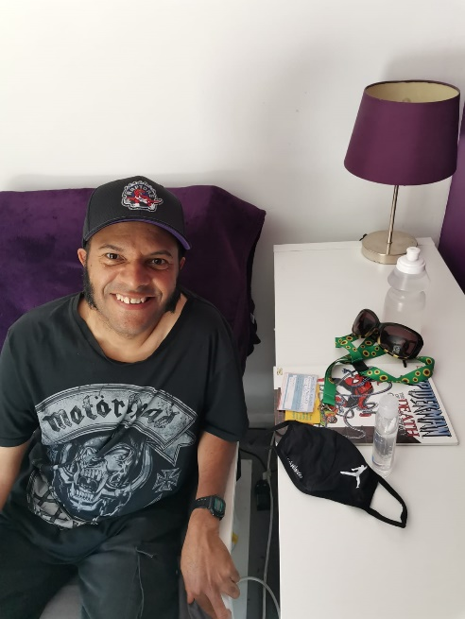 | This is me getting ready at home.  I am making sure I have my:  - Face Covering  - Tissues  - Hand gel  - Drink  - Comic book  - Sunflower lanyard  - Thumbs up card
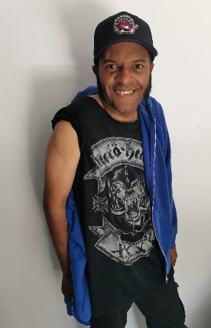 | To make it easy to have the jab (vaccination), I am wearing a t-shirt and hoody.
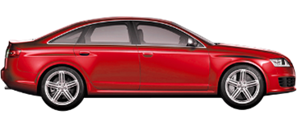 | I am going in the car with my brother today.  If you need help to get to the Racecourse you can  book free transport.  Phone 01444 275008  Open: Monday to Friday  10:00 to 1:00  and  2:00 to 5:00
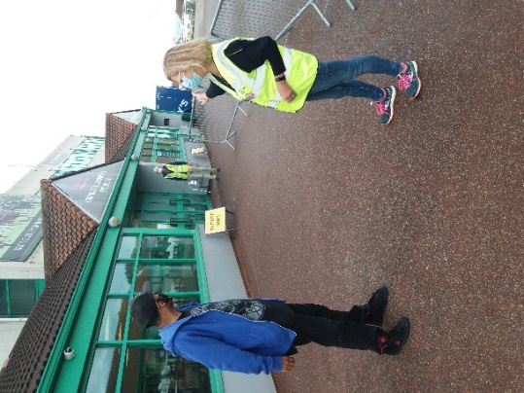 | When I got to the Racecourse,  staff in yellow tops showed me  where to go.
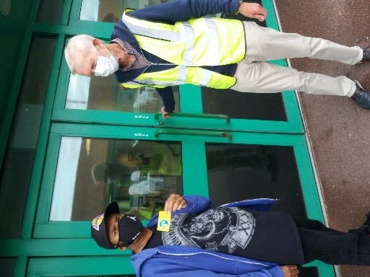  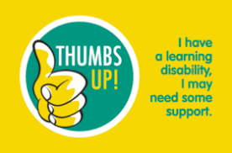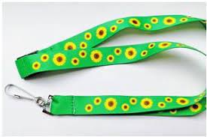 | When I got to the front door,  I showed the staff my Speak Out thumbs up card and sunflower lanyard.  I told them I have a learning disability.
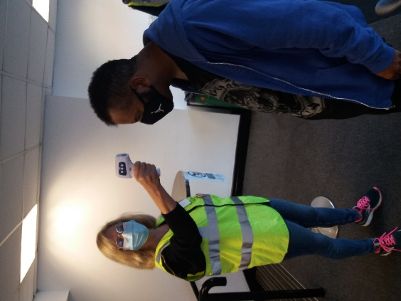  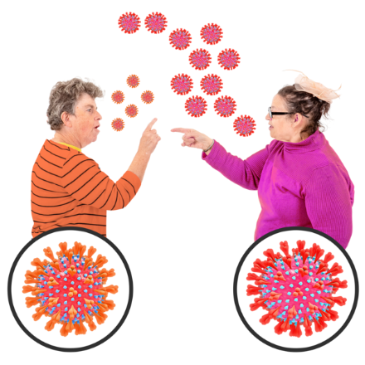  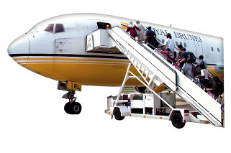  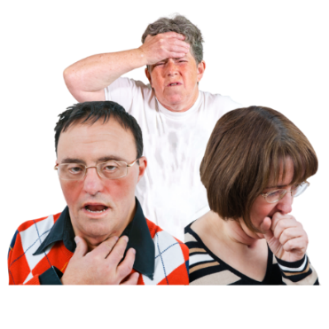 | When I got inside, the staff took my temperature.  To check I haven’t got Covid-19, the staff asked me:  Do you, or people in your house have Covid?  Are you, or people in your house waiting for a Covid-19 test result?  Have you met with anyone who has been told they have Covid-19?  In the last 10 days have you travelled out of the country?  Do you have any of these symptoms?  • high temperature or fever  • new continuous cough  • loss or alteration to taste or smell
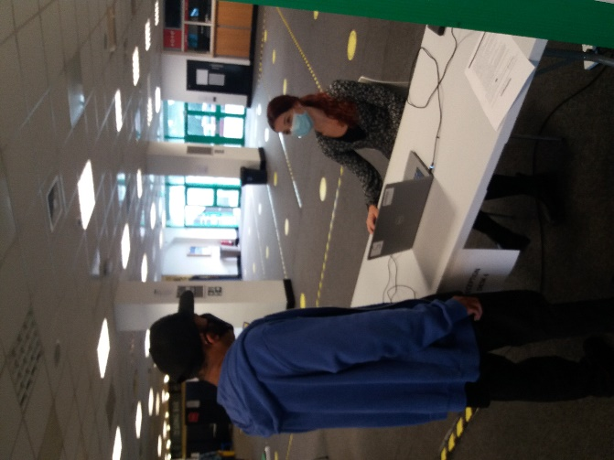 | This is me at the reception desk.  The staff asked me these questions:  - Have you got an appointment?  - What is your name?  - What is your date of birth?  They gave me a form to give to the person doing the vaccination and easy read information.
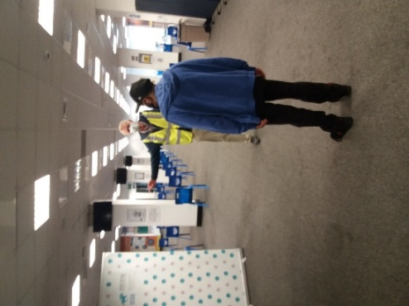 | The staff in yellow tops took me to the person doing the jab (vaccination).
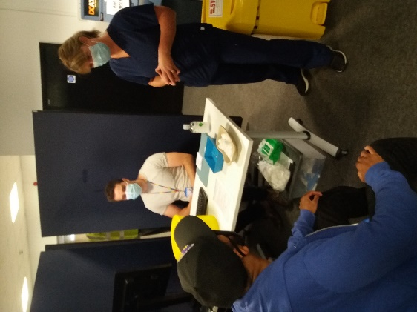 | The person doing the jab (vaccination) asked me these questions:  - My name  - My date of birth  - My ethnicity  - Am I allergic to any medication?  - How I felt after my 1st Covid-19 vaccination?  - In the last 7 days have I had any other vaccinations?  - Am I on a Covid-19 trial?  - Am I on any medication that makes my blood thin?  - They ask females if they are pregnant?  My Brother helped me answer the questions.
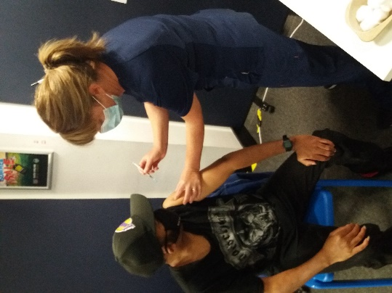 | This is me having my jab (vaccination).  Relax, try not to worry about it,  It’s not as bad as you think.
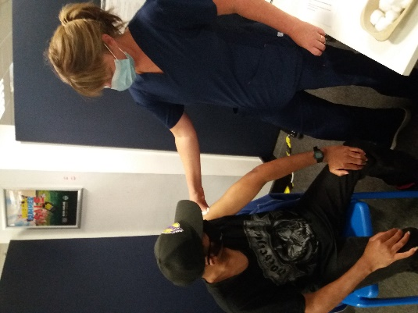 | After you have the jab (vaccine), the nurse put cottonwool on my arm.
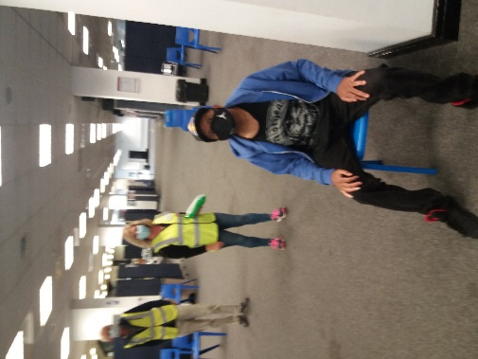 | I had to rest for 15 minutes after the jab (vaccination).  I was pleased I brought my comic book, so I had something to do.
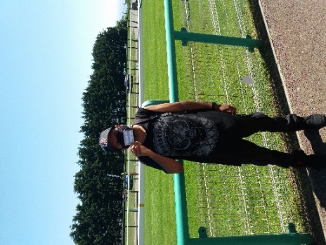 | This is me after the jab (vaccination).  I felt happy that I got my jab (vaccination) done.  Its nothing to worry about because it helps to keep you safe.
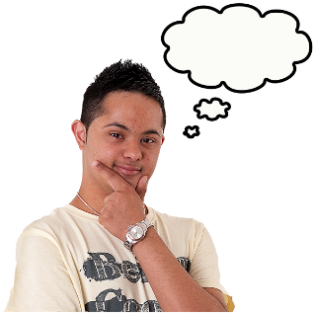 | If you have questions about the  Covid-19 jab (vaccine) you can phone:  Phone: 0800 433 4545  Open 9am to 4pm, Monday to Friday.
 | A very big thank you to Mike for sharing his story.
This story was made for the Racecourse Vaccination Centre by:
Mike and Jane Viner
Learning Disability Health Facilitator
Jane.viner@brighton-hove.gove.uk
August 2021

