- Remain calm; be patient, tolerant and understanding.

- Address me by name each time you speak to me.

- Autistic people can be vulnerable. They are entitled to an Appropriate Adult. This should be arranged immediately.

- Be aware your behaviour and language can be confusing to me.

Always explain what is happening, what will happen and why.

- Be aware autistic people may carry an object for comfort to help manage stress & anxiety; removing it can cause extreme distress. Only remove it if essential.

- Don’t touch me or use handcuffs unless essential for safety.
My name is

How you can help me
Autism Passport
Date of birth

Phone Number

Email Address
I like to be called

Postal Address

5. Keep your language clear, concise and unambiguous.
12. Be aware autistic people may

not notice if they are injured.

- Use short, single clause sentences and direct commands.

Ask one question at a time,
13. Autistic people can be sensitive to, scared by, crowded noisy places, loud noises, touch and lighting. Find the quietest, least busy, place possible; try

I am entitled to have an Appropriate Adult with me at all times. Please contact my Appropriate Adult immediately so I have the support I need.

Thank you.

and allow extra time for me to respond – at least 8-10 seconds before asking more.

8. Autistic people may have a different understanding of personal space: standing too close doesn't mean they are being confrontational, and standing at a distance doesn't mean they intend to flee.
to be reassuring.

Avoid sudden and unexpected changes.

- Keep timings realistic and update any changes; avoid being specific about timings; you may be taken literally and cause distress if you deviate from the time you have given.
Appropriate Adult name

Relationship to me

Phone Number
Appropriate Adult name

Relationship to me

Phone Number

How I communicate
About me
Ask me how I am feeling

How to communicate with me
Go Be Careful Stop

Things that cause me distress

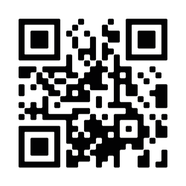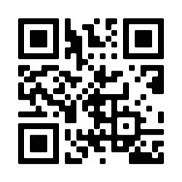Things you can do to help me
Emergency chat can be used in any situation where speech is impossible but communication is still necessary. Scan the QR code below:
iPhone:
Android:
good - happy
- working well

An autistic person may:
confused - not listening
- need to think
angry - very upset

Sensory difficulties: things that cause me discomfort

Other medical conditions

Other information about me

Medications I take and dosage

  - Avoid eye contact or display minimal or unusual eye contact.

  - Behave in an unusual, inappropriate or unpredictable way when anxious, stressed or confused.

  - Find it difficult to cope in new and unfamiliar situations.

  - Find it difficult to express emotions, feelings and their needs.

  - Find it difficult to know how you are feeling and may seem insensitive, rude or blunt.

  - Not understand consequences of their actions or have no concept of danger.

  - Dislike physical contact: physical contact is to be avoided.
- Have difficulty understanding verbal and non-verbal communications.

- Need extra time to process what is said to them.

- Seem argumentative, stubborn, extremely agitated or over- compliant.

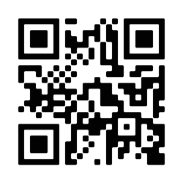
In addition to this Autism Passport we encourage you to sign up to the Pegasus card scheme:

Sussex Police Pegasus card scheme is for people who find it hard to
communicate with us – we keep your pre-registered information safe on our computer and we can access it quickly if you call us. You don’t need to repeat all your details.

