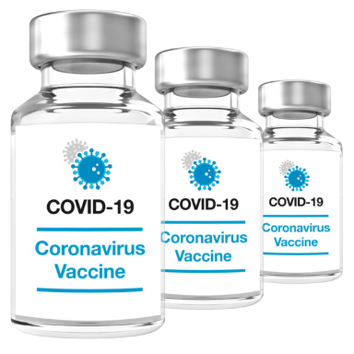 |  |  |  | COVID-19 Vaccination  Reasonable Adjustments |  | 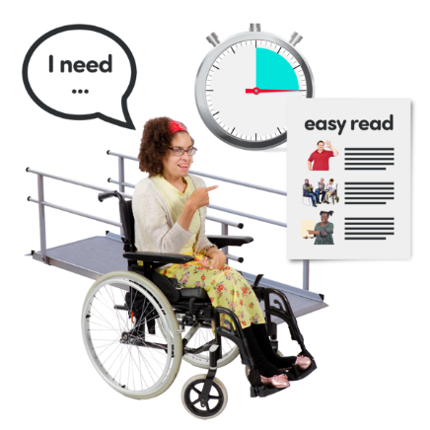
About me
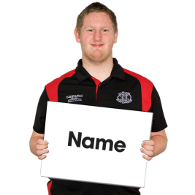 |  |  |  |  | Name:
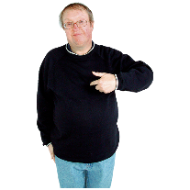 |  |  |  |  | I like to be called….
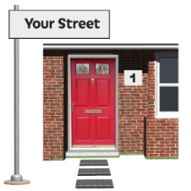 |  |  |  |  | Address:
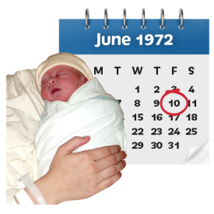 |  |  |  |  | Date of birth:
 |  |  |  |  | Phone:
 |  |  |  |  | Email:
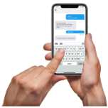 |  |  |  |  | Please remind me of appointments by ......
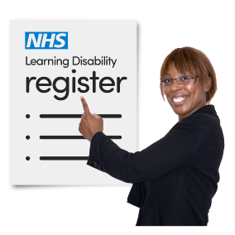 |  | GP Learning Disability Register
People on the GP Learning Disability Register, will be offered a yearly Health Check and invited for the Covid-19 and Flu vaccinations.

If you have a Learning Disability and would like to go on the GP Register,
Please circle

 |  |  |  |  | I have a Learning Disability and would like to go on the GP Learning Disability Register
 |  |  |  |  | I do not have a Learning Disability
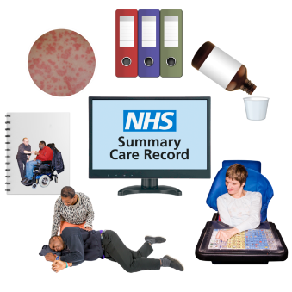 |  |  | Summary care records
If you would like extra information on your summary care record about your health and what support (Reasonable Adjustments), you need let your Doctor know
Please circle

Easy read resources about Summary Care Records: https://www.mencap.org.uk/sites/default/files/2019-05/SCR_AI_Easy_Read_Patient_Leaflet.pdf
 |  |  |  |  | I would like extra information on my Summary Care Record
I do not want extra information on
my Summary Care Record
Reasonable Adjustments

A reasonable adjustment is a change your Doctor needs to make so going to the surgery is easier for you.

Please tick the box’s for ways we can help you.

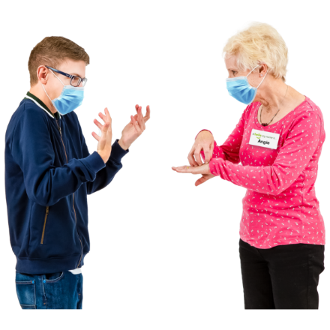 | Take your time and use my name when you talk to me.
 | Please use everyday words and short simple sentences.
 | Lots of ‘chat’ can be too much for me.
 | I need information with pictures (easy read).
 | I need information in Braille
I need information in
Large print.

 | I need an interpreter.
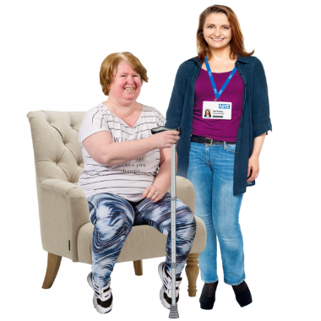 | I may need a home visit.
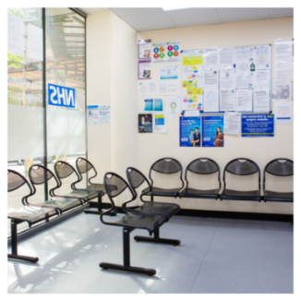 | I would like to come at quiet times, because I find it difficult waiting  for my appointment.
 | I may need to wait outside until you are ready to see me.
Bright lights or loud
Noises may affect me.

 | I need to wait away from other people
 | Can I wait somewhere quiet for a while before I go home
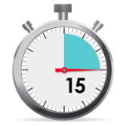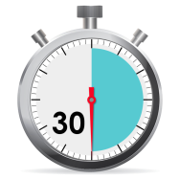 | I need longer Appointments
 | I might get agitated |  | If I do, it looks like this.......
 |  |  | You can help by ......
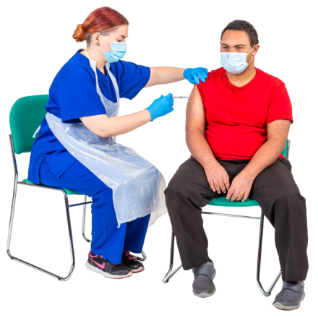 | Support I need having the Vaccination.
Tell me what you are going to do first.

Give me time to think about what you have said.

Let me know when you are ready.

I will let you know I’m ready, by….

(saying OK, signing, nodding, pointing to my comms device etc)

 | Ways you can support me…..
 | How I have coped with having jabs (Vaccinations) in the past….
My carer will support you
to understand my needs.

I get very nervous at
appointments and need
my carer to support me.

 | My Carer may help me answer your questions.
Please tell my carer
about any appointments.

 | More things that might help us both to get my vaccination done well……
 | Adapted from the Sussex CCG’s “getting ready for your annual health check” guide By: Amaze, PaCC and Brighton & Hove City Council Health Facilitator jane.viner@brighton-hove.gov.uk 04/03/2021

