My Story: Back to School

My name is ….
I go to …. School.
I am going back to school on ….
I go to school by (taxi, minibus, school bus)
Some things will be different.
This is because of the virus.

I might see my old driver and VPA again.
But I may have a new driver and VPA for a while.
If I do, my new driver and VPA will still be kind to me.
They will say hello and goodbye.
They will want to get to know me and what I like.

I may have to sit somewhere different.
This is to help keep everyone safe.
My driver and VPA may be wearing a mask and gloves like in these pictures
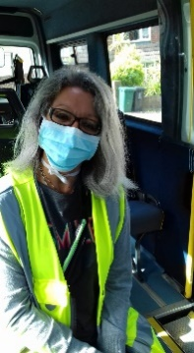
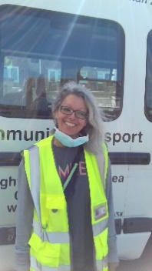

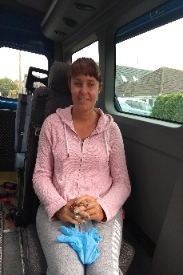
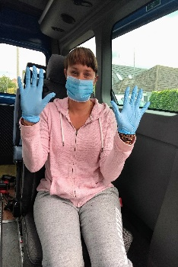

This is to help keep everyone safe.
If I am worried, I can tell (mum/dad/ carer).
School is fun.
I can see my teachers and friends again.

