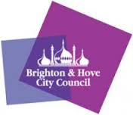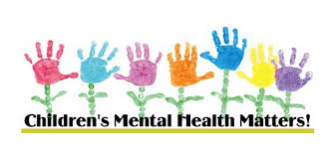

Dear Parents/Carers,

Do you have a child or young person at school in Brighton & Hove?

**If you have any concerns about their Emotional Mental Health and Wellbeing you are invited to talk to a Primary Mental Health Worker from the Schools Wellbeing Service.**

* Telephone consultations are available whilst schools are closed
* **Please email** [**SWSConsultationLine@brighton-hove.gov.uk**](mailto:SWSConsultationLine@brighton-hove.gov.uk)

**Or call 01273-293481**

You will need to send/leave us your name and phone number and a Primary Mental Health Worker will call you back.

Whilst we aim to call back within two days, please be aware we may have a high demand so your patience is appreciated.

**This is not a crisis number – if you require immediate support you need to contact your GP, call CAMHS duty care on 03003040061 or go direct to A&E**

**For information on different services available, please visit findgetgive.com**