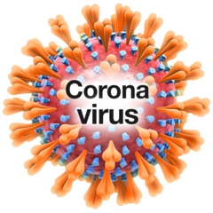 | Because of Coronavirus people need to wear face masks on the bus.
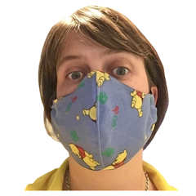 | Wearing face masks makes some people anxious.
If you have a disability you are exempt.

This means you do not have to wear one.

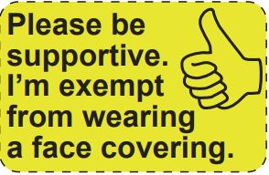 | Don’t be worried if someone asks why you are not wearing a mask.  You can show them this card to explain.
To find out more about Helping Hand cards go to Brighton & Hove Buses website
https://www.buses.co.uk/helpinghand

Brighton & Hove Buses customer support
01273 886200

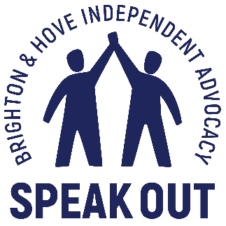 | Help and support for people with learning disabilities  Speak Out Helpline  01273 421921

